WORKING WINDMILL USING COMPUTER GRAPHICS
Group Members:
1. Fatir Khan (24111590783)
2. Farzan Khan (24111590786)
3. Hamza Ansari (24111590797)
4. Danish Solkar (24111590805)
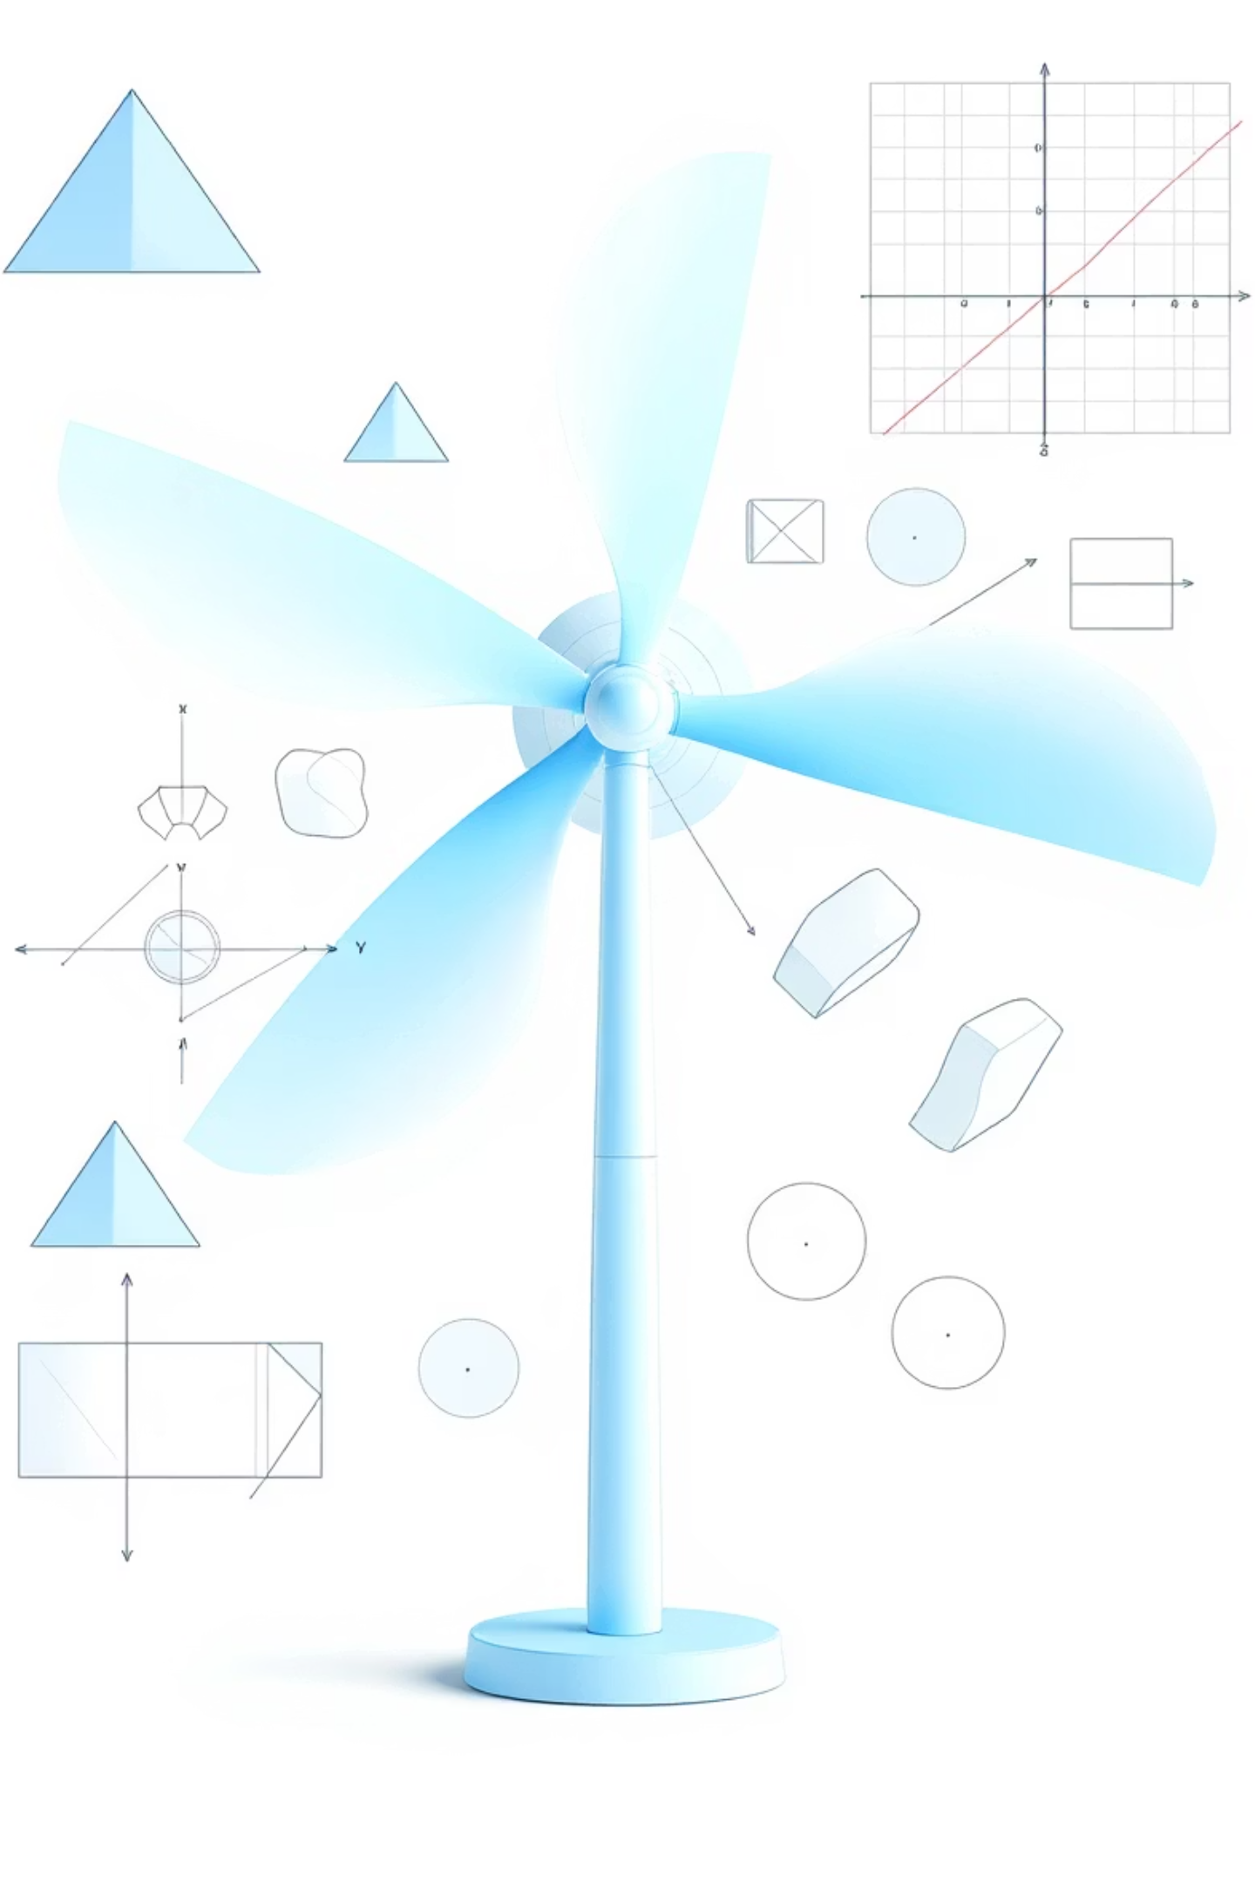
INDEX
Topics:
1. Abstract
2. Introduction
3. History / Working
4. Circuit Diagram / Diagram
5. Application
6. Conclusion
7. References
Table Index:
Table 1: Hardware Requirements
Figure Index:
Figure 1: Windmill Animation Structure

ABSTRACT
The project “Working Windmill Using Computer Graphics” demonstrates the implementation of basic graphical transformations to simulate the motion of a rotating windmill using the C programming language and the graphics.h library. The main objective of this project is to visualize the concept of rotation and scaling in two-dimensional computer graphics by animating windmill blades that rotate continuously around a fixed axis. Trigonometric functions such as sine and cosine are used to calculate the dynamic coordinates of the blades, providing smooth and realistic motion.
The project operates through a continuous animation loop, which clears the previous frame, updates blade positions, and redraws them to create a flicker-free rotation effect. This approach highlights the importance of screen refresh cycles and frame control in real-time graphical simulations. Additionally, the project incorporates basic scaling transformations to represent changes in visual perspective, such as wind intensity or distance.
This micro-project serves as an educational model to understand the practical use of computer graphics concepts, including coordinate geometry, transformation matrices, and real-time rendering. It also encourages analytical thinking by connecting mathematical logic with programming principles. Overall, the project successfully illustrates how simple coding techniques can produce dynamic and visually appealing graphical animations that mimic real-world mechanical systems.
Keywords: Computer Graphics, Rotation, Scaling, Animation, Windmill Simulation, Trigonometry

1. INTRODUCTION
Computer Graphics is one of the most fascinating fields in computer science, allowing programmers to create and manipulate visual content using mathematical and logical concepts. This project, titled “Working Windmill Using Computer Graphics,” focuses on simulating the motion of a windmill using simple graphical transformations in the C programming language. It demonstrates how mathematical formulas, particularly trigonometric functions, can be applied to achieve realistic motion and animation in two-dimensional (2D) graphics.
The main goal of this project is to depict a continuously rotating windmill by applying the concept of rotation transformation, where the position of each blade is recalculated at small time intervals. The animation is achieved through an iterative loop that clears the screen, updates the blade angles, and redraws the image, creating the illusion of smooth and continuous movement.
By implementing this project, students gain hands-on experience with fundamental computer graphics concepts such as coordinate systems, transformations, and real-time animation. It bridges the gap between theoretical mathematics and visual programming, helping learners understand how dynamic objects can be modeled and controlled programmatically. Overall, this project provides a strong foundation for developing more advanced graphical applications and interactive simulations.

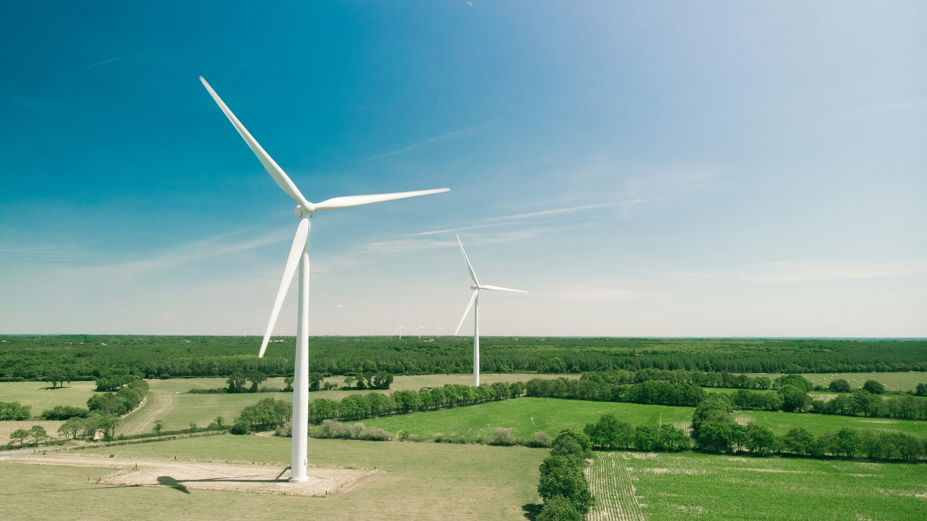

2. HISTORY / WORKING
The concept of the windmill dates back to ancient times when it was used as a mechanical device to convert wind energy into useful forms of power, such as grinding grains or pumping water. Over time, the design and purpose of windmills evolved into modern wind turbines, which convert wind energy into electrical energy. In the field of computer graphics, the same concept can be simulated visually to demonstrate motion, rotation, and energy conversion principles through graphical transformations.
In this project, the Working Windmill is created using C programming with the graphics.h library. The main objective is to simulate the continuous rotation of the windmill blades using mathematical and logical operations. The working of the project relies on trigonometric functions (sine and cosine) to calculate the changing positions of the blade ends as they rotate around a central hub.
The program operates through an animation loop, where each frame performs the following steps:
- Initialize the graphics mode and define the center of the windmill.
- Draw the tower and the rotating blades at fixed angular intervals.
- Increment the rotation angle for each frame.
- Clear the screen using the cleardevice() function to avoid overlapping of frames.
- Redraw the windmill with updated blade positions.
- Continue the process until a key is pressed to stop the animation.
This process gives the illusion of smooth and continuous blade rotation, similar to the working of a real windmill. The project thus provides a visual and practical understanding of rotation transformation, screen refreshing, and real-time animation concepts in computer graphics.

3. PROGRAM
#include <graphics.h>
#include <conio.h>
#include <math.h>
#include <stdio.h>
#define PI 3.14159265
void drawBlade(int cx, int cy, int length, float angle)
{
int x, y;
x = cx + (int)(length * cos(angle * PI / 180.0));
y = cy + (int)(length * sin(angle * PI / 180.0));
line(cx, cy, x, y);
}
int main()
{
int gd = DETECT, gm;
int midx, midy;
int i;
float theta = 0; /* rotation */
float scale = 1.0; /* scaling */
float ds = 0.02; /* scaling speed */
initgraph(&gd, &gm, "C:\\Turboc3\\BGI");
midx = getmaxx() / 2;
midy = getmaxy() / 2;
outtextxy(10, 10, "Press any key to stop windmill...");
while (!kbhit()) {
cleardevice();

/* --- Windmill Base --- */
setcolor(WHITE);
rectangle(midx - 20, midy, midx + 20, midy + 120);

/* --- Windmill Tower --- */
setcolor(LIGHTGRAY);
line(midx, midy, midx, midy - 100);

/* --- Blades (rotation & scaling only) --- */
setcolor(CYAN);
for (i = 0; i < 4; i++) {
drawBlade(midx, midy - 100, (int)(60 * scale), theta + i * 90);
}

/* update transformations */
theta += 5; /* rotate */
if (theta >= 360) theta = 0;

scale += ds; /* scale */
if (scale > 1.5 || scale < 0.5) ds = -ds;

delay(100); /* control animation speed */
}
getch();
closegraph();
return 0;
}

4. CIRCUIT DIAGRAM / DIAGRAM
The project does not include an electrical circuit but involves a graphical representation of a windmill structure. The program logic forms the foundation of the design that represents motion visually.
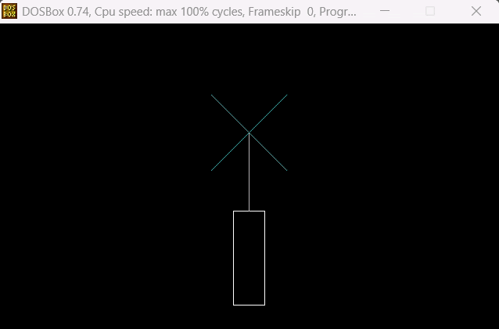

5. APPLICATION


1. Educational demonstrations for computer graphics learning.
2. Basis for understanding 2D transformations in graphics.
3. Visualization of physical concepts such as rotation.
4. Used as a foundation for creating advanced animation projects.
5. Demonstrates real-time simulation logic using C programming.

6. CONCLUSION
The working windmill project using computer graphics effectively demonstrates the principles of wind energy conversion and mechanical motion in a visually engaging manner. By simulating the windmill’s rotation and blade movement, the project provides a clear understanding of its operational dynamics without the need for a physical model. This approach not only enhances learning and visualization but also highlights the potential of computer graphics in engineering education and design simulations. Overall, the project successfully combines theoretical knowledge with practical visualization, making it a valuable tool for both study and demonstration purposes.

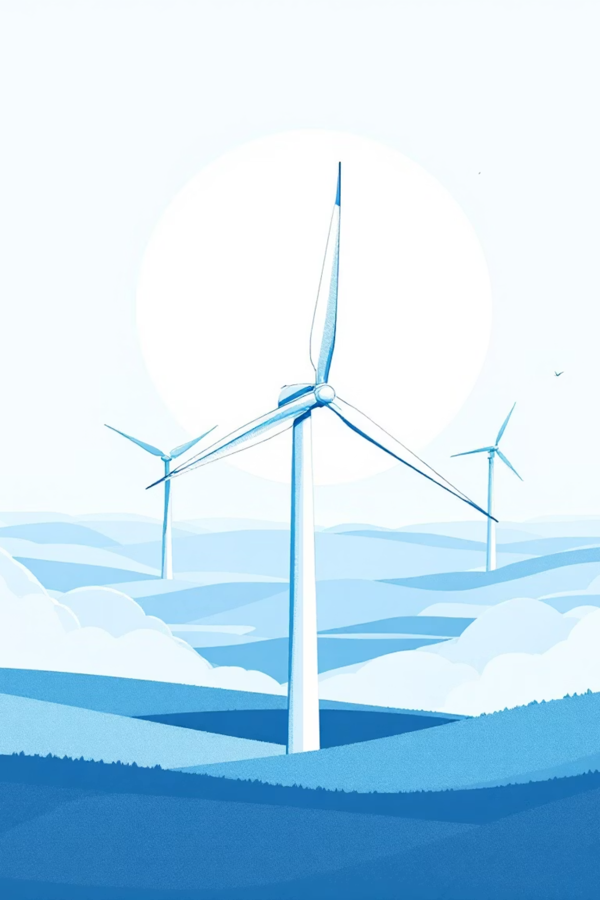

7. REFERENCES
1. Foley, J. D., van Dam, A., Feiner, S. K., & Hughes, J. F. (1995). Computer Graphics: Principles and Practice.
2. Donald Hearn and M. Pauline Baker, Computer Graphics, C Version, Pearson Education.
3. https://www.geeksforgeeks.org/computer-graphics-rotation/
4.https://www.tutorialspoint.com/computer_graphics/2d_transformation.htm

